



To create the ALTER Statement using Library Management System
LAB MANUAL

Disclaimer: The content is curated from online/offline resources and used for educational purpose only
To create the ALTER Statement using Library Management System
Objective:
To demonstrate the use of SQL ALTER statements to modify the structure of existing database tables by adding, modifying, or removing columns and constraints. This will ensure the database schema meets the evolving requirements of the Library Management System.

Problem Statement:
In Library Management System, the database schema might need updates to accommodate new features or improve performance. Current issues include:
- Missing information about the genre of books.
- Insufficient size for the Email column in the Members table, which might fail to store longer email addresses.
- The need to remove unused or redundant columns, such as ReturnDate, in the Transactions table.
- Lack of a unique constraint on the Email column, which can lead to duplicate member entries.

Requirements:
- MySQL Server installed and configured.
- MySQL client tool such as MySQL Workbench or CLI access.
- Database: LibraryDB
- Tables: Books, Members, Transactions
- SQL Privileges: User must have ALTER permissions on the tables.

Procedure:
Step A: Add a Column to the Books Table
Add a new column Genre to the Books table to store the genre of each book.
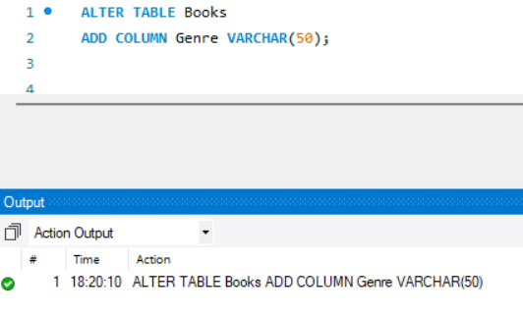
Specifies the table to be altered and adds a new column named Genre with a data type of VARCHAR (maximum length 50).

Step B: Modify a Column in the Members Table
Increase the size of the Email column to VARCHAR(150) in the Members table.
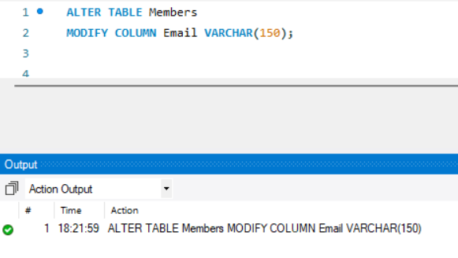
Specifies the table to be altered and changes the Email column’s maximum length to 150 characters.
Step C: Drop a Column from the Transactions Table
Remove the ReturnDate column from the Transactions table.

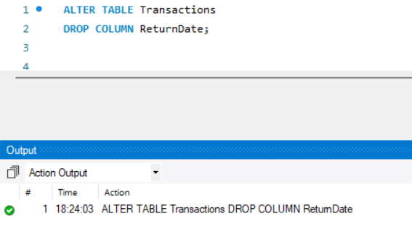

Specifies the table to be altered and removes the ReturnDate column permanently.
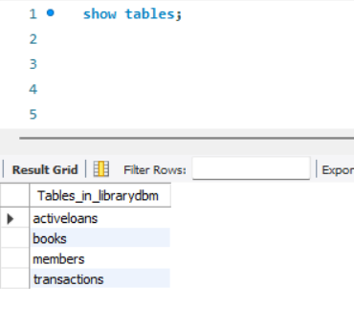

Step D: Add a Unique Constraint to the Email Column in the Members Table
Ensure the Email column in the Members table has a unique constraint to prevent duplicate entries.
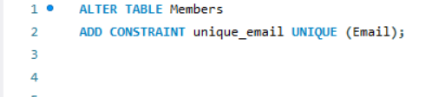
Specifies the table to be altered and adds a unique constraint to the Email column and names it unique_email.
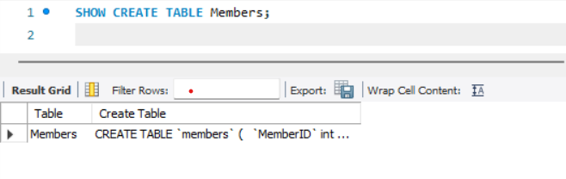

Use the SHOW CREATE TABLE command to verify the constraint

Output:
The queries was successfully executed

